1. **like name comment and notifications must be there - pop up dialog**
2. **send private message - on connected selected friend...**
3. **all - recommended buyers/suppliers must be with same business category who are not in VR**
4. **advertisement - ads must be visible at VR area / transaction area**
5. **No way to delete the messages. We had that option previously.**
6. **Search - search a buyer and supplier and send VR request or Send RFQ to selected ones**
7. **global notification redirection of buyer VR supplier VR to diff diff**
8. **global notification redirection of transaction to diff diff**
9. **facebook like ping sound on chat / message / global notification**
10. **selected event must be opened for selected record via global notification**
11. **press button/show circle of loading**
12. **When I accepted the invitation the accept box should change. Also the person shows in My connections when I refresh the page**

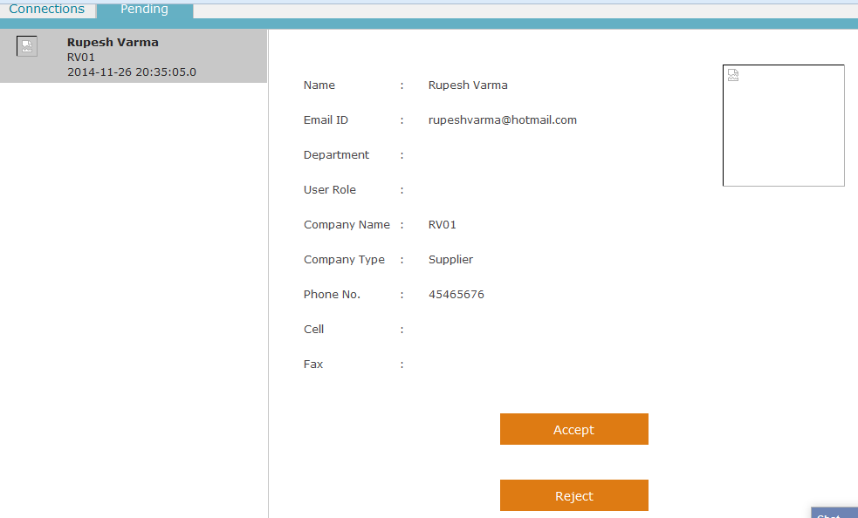

1. **New company registration page on IE8**

Machine generated alternative text: Info
ranch
Sign Up  Buyer Seller 1 Buyer/Supplier
Country/Region
Logo Browse
Address
Company Name
City
Company Id
. State/Province
Segment/Division Name
Zip Code/Postal Code
Business Unit Name
Add Address
Business Category* fl-Select Categorr
Cancel I Next